Veer Narmad South Gujarat University,Surat.

Department of Information and Communication Technology



ProjectReport

1ST Semester

M.Sc.(Information and Communication Technology)

2 YearCourse

Year 2019-2020

**“Online Agricultural Shop”**

Guided By: Submitted By:

Dr. Veena Jokhakar Yashpalsingh g. Rajpurohit

**Veer Narmad South Gujarat University, Surat.**

**M.Sc. (Information Communication Technology)**

**Certificate**

This is to certify that **Yashpalsingh G. Rajpurohit** withExam Seat Number **10001** has satisfactorily completed his project work entitled as ‘**Online Agricultural Shop’** as a partial fulfillment of the requirements for **1stSemester - M.Sc.(Information & Communication Technology)** during the academic Year 2019-2020.

**Date: Place:**

29/10/2020 J.P. Dawer,Surat

**Co-ordinator:**

M.Sc. (I.C.T.) Programme.

VNSGU, SURAT

**Acknowledgement**

First and foremost, praises and thanks to the Almighty God, for His showers of blessings throughout the work to complete the project successfully.

We would like to express our deep and sincere gratitude to **Dr. Kamlendu Pandey** and all our Professors for their expert advice, encouragement and helping us throughout this project.

We would specially like to thank **Dr. Veena Jokhakar** for providing valuable advise, guiding us throughout the Project.

We are extremely grateful to our parents for their love, prayers, care and support.

We would also like to thank all our friends who always helped and supported us to complete the project

Last but not the least we would like to thanks all the colleagues who have really motivated us in the project work.

**Thanking All Yashpalsingh Rajpurohit**

1. **Introduction**
   1. **Project Profile**

**Project Profile**

**Project title** : ‘Online Agricultural Shop’

**Name of Institute** : J.P. Dawer Institute OF Science And Technology ,

Veer Narmad South Gujarat University,Surat.

**Front End Tool** : JSF (XHTML) , HTML

**Back End** : XAMPP v3.2 ,REST , JPA

**Operating System**  : Window 10

**Other Technology** : JavaScript, JSF, Bootstrap, CSS.

**Project Guide** : Ms. Veena Jokhakar.

**Submitted by** : Yashpalsingh G. Rajpurohit

1. **Environment Description**

**2.1 Hardware & Software Requirements**

**2.2 Technology Used**

**Hardware & Software Requirements**

* **Hardware Specification :**

**Processor** : Intel(R) Core(TM) i5-7200U CPU @ 2.50GHz 2.70

**RAM** : 4.00GB (3.79 GB usable)

**Hard Disk** : Basic 931.51 GB Online

**Monitor** : 15.6” HD True Life Display

**System Type** : 64-bit Operating System, x64-based processor

* **Software Specification:**
* **Software Requirements (for Development):**
* Integrated Development Environment (IDE 8.2) (NetBeans)
* JDK v1.8 (Java Development Kit)
* XAMPP Control Panel v3.2.2
* **Operation System (for development):**
* Microsoft Windows 10 Enterprise
* **Server Configuration:**
* Payara Version: 5.0
* NetBeans Version: 8.2
* XAMPP v3.2.2
* **For Client Side:**
* Mozilla Firefox / Google Chrome / Any HTML5 And CSS3 Browser
* **Technology Used:**
* J2EE
* Java Script
* JSF(Java Server Faces)
* Bootstrap
* CSS
* MYSQL
* REST

1. **Proposed System**

**3.1 Project Propose**

**3.2 Project Scope**

**3.3 Project Objective**

* **Project Propose:**
* Main objective of proposed system is to design computerized system to let users buy agricultural products.
* To give security to system by login and password.
* Design system that is user-friendly and easy to operate.
* To buy agricultural product any time.
* To provide agro products to user at their doorstep.
* To provide various agricultural products in rural area which are unavailable there.
* **Project Scope:**
* **Admin Side** :-
* Login
* Admin can add brand.
* Admin can add various Categories.
* Admin can add Products.
* Admin can add Cities.
* Admin can add States.
* Logout

* **Client Side**
* Register
* Login
* View Products
* Can Order AgroProducts.
* Payment
* Search Products
* Logout
* **Project objectives :**
* Online Agricultural Shop is website that is used to order agro products Online.
* It saves a lot of time, energy & money, moreover it provides quick & efficient services.
* The main aim of the project is to create web-based software which allows user to order products related to agriculture .
* Project purpose is to save time and efforts.
* This website provides all types of agriculture related stuffs like fertilizers ,seeds , machinery related to agriculture and much more.

1. **Unified Modeling Language**

**4.1 Use Case Diagram**

**4.2 Sequence Diagram**

* **Use Case Diagram :**

**Admin:-**

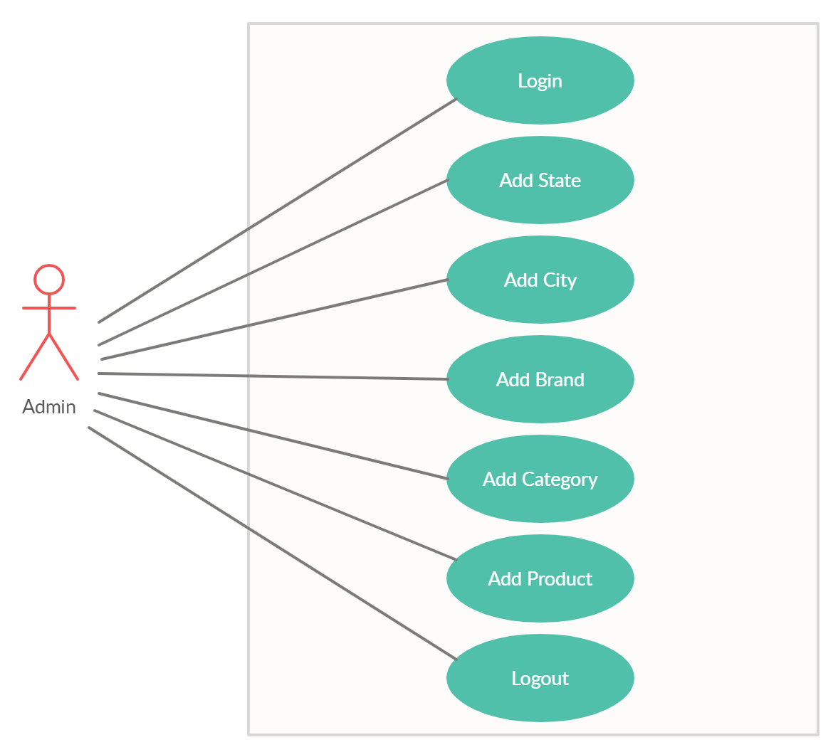

**User:-**

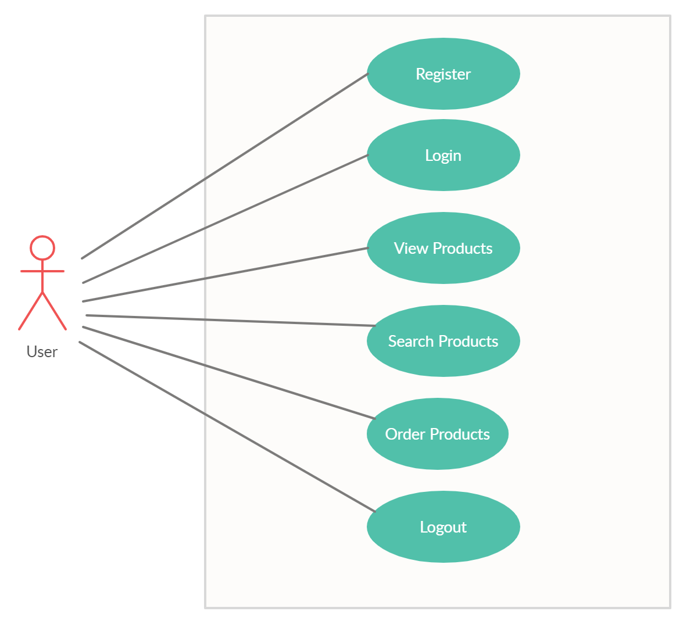

* **Sequence Diagram :**

1. **Admin Side:**

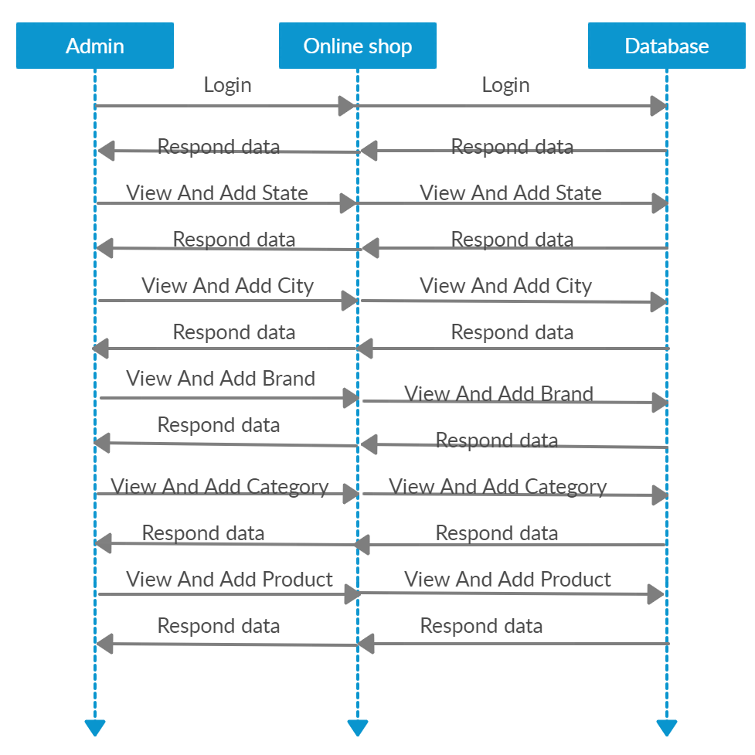

1. **User Side:**

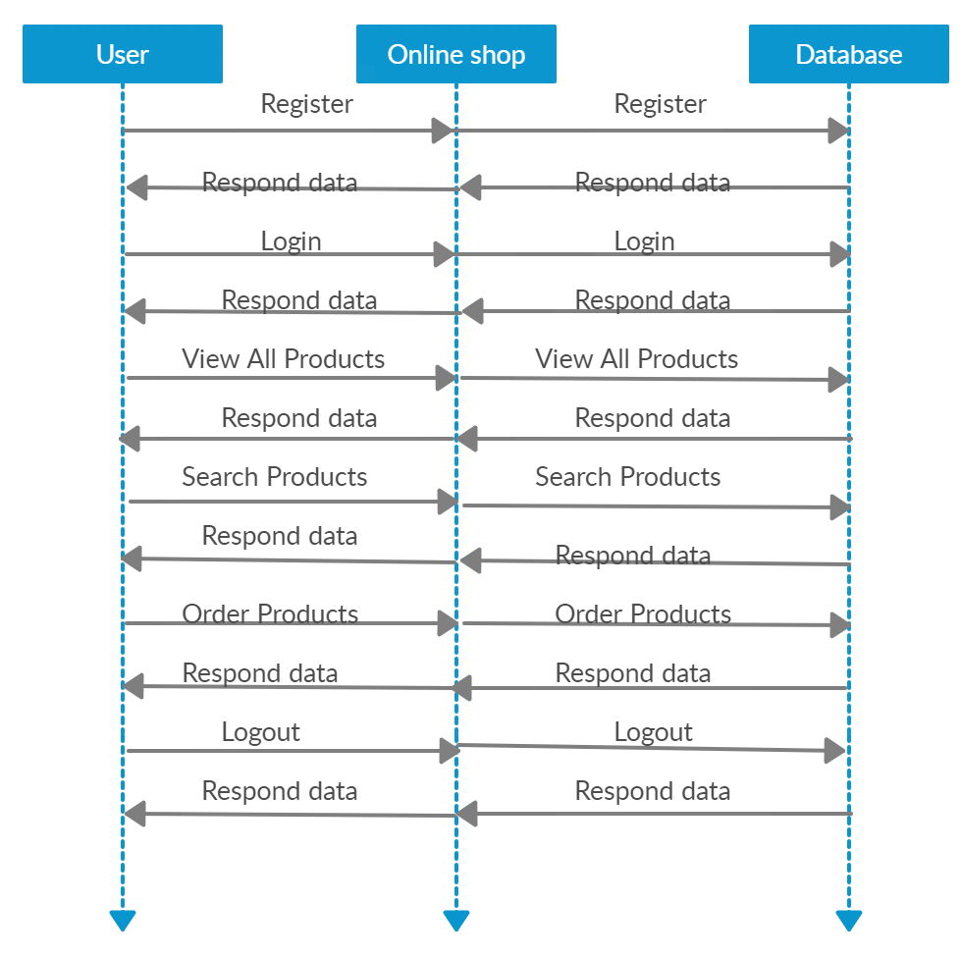

1. **System Design**

**5.1 Relationship Diagram**

**5.2 Database Diagram**

* **Relationship Diagram:**

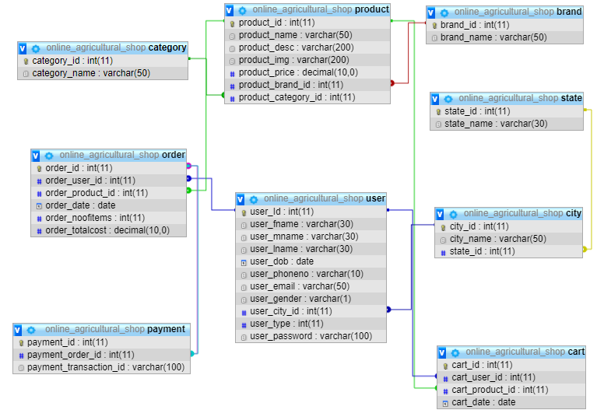

* **Database Diagram :**

1. **Table Name :** brand

|  |  |  |  |
| --- | --- | --- | --- |
| Sr.No. | Field Name | Datatype | Constraint |
| 1 | brand_id | int(11) | Primary Key |
| 2 | brand_name | varchar(50) |  |

1. **Table Name:** category

|  |  |  |  |
| --- | --- | --- | --- |
| Sr.No. | Field Name | datatype | constraint |
| 1 | category_id | int(11) | Primary Key |
| 2 | cateogry_name | varchar(50) |  |

1. **Table Name:** state

|  |  |  |  |
| --- | --- | --- | --- |
| Sr.No. | Field Name | Datatype | constraint |
| 1 | state _id | int(11) | Primary Key |
| 2 | state_name | varchar(30) |  |

1. **Table Name:** city

|  |  |  |  |
| --- | --- | --- | --- |
| Sr.No. | Field Name | Datatype | constraint |
| 1 | city_id | int(11) | Primary Key |
| 2 | city_name | varchar(50) |  |
| 3 | state_id | Int(11) | Reference from state table |

1. **Table Name :** product

|  |  |  |  |
| --- | --- | --- | --- |
| Sr.No. | Field Name | Datatype | constraint |
| 1 | product_id | int(11) | Primary Key |
| 2 | product _name | varchar(50) |  |
| 3 | product _desc | varchar(200) |  |
| 4 | product_price | decimal(10,0) |  |
| 5 | product _img | varchar(200) |  |
| 6 | product _brand_id | int(11) | Reference from brand table |
| 7 | product _category_id | int(11) | Reference from category table |

1. **Table Name:** user

|  |  |  |  |
| --- | --- | --- | --- |
| Sr.No. | Field Name | Datatype | constraint |
| 1 | user_Id | int(11) | Primary Key |
| 2 | user _fname | varchar(30) |  |
| 3 | user _mname | varchar(30) |  |
| 4 | user _lname | varchar(30) |  |
| 5 | user _dob | date |  |
| 6 | user _phoneno | varchar(10) |  |
| 7 | user _email | varchar(50) |  |
| 8 | user _gender | varchar(1) |  |
| 9 | user_city_id | int(11) | Reference from city table |
| 10 | user_type | int(11) |  |
| 11 | user_password | varchar(100) |  |

1. **Table Name:** cart

|  |  |  |  |
| --- | --- | --- | --- |
| Sr.No. | Field Name | Datatype | constraint |
| 1 | cart _id | int(11) | Primary Key |
| 2 | cart_user_id | int(11) | Reference from user table |
| 3 | cart_product_id | int(11) | Reference from product table |
| 4 | cart_date | date |  |

1. **Table Name:** order

|  |  |  |  |
| --- | --- | --- | --- |
| Sr.No. | Field Name | Datatype | constraint |
| 1 | order_id | int(11) | Primary Key |
| 2 | order_user_id | int(11) | Reference from user table |
| 3 | order_product_id | int(11) | Reference from product table |
| 4 | order_date | date |  |
| 5 | order_noofitems | int(11) |  |
| 6 | order_totalcost | Decimal(10,0) |  |

1. **Table Name:** payment

|  |  |  |  |
| --- | --- | --- | --- |
| Sr.No. | Field Name | Datatype | constraint |
| 1 | payment_id | int(11) | Primary Key |
| 2 | payment_order_id | int(11) | Reference from order table |
| 3 | payment_transaction_id | varchar(100) |  |

1. **Interface Design**

Registration Page:

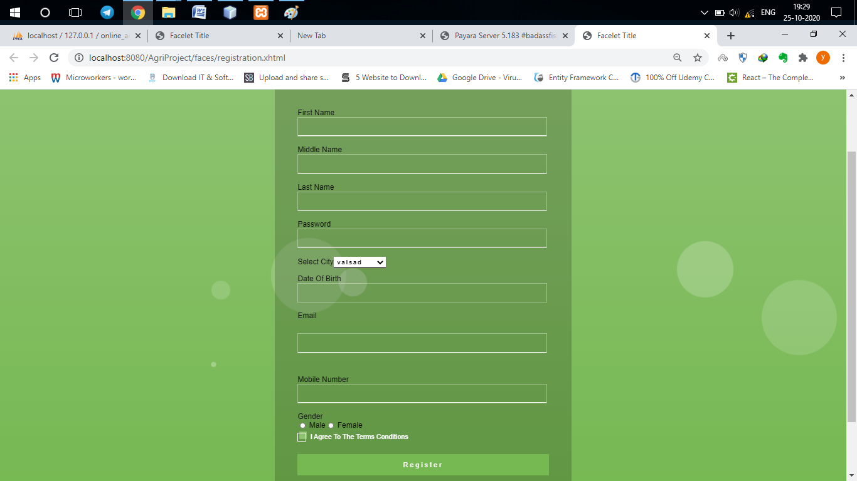

Login Page: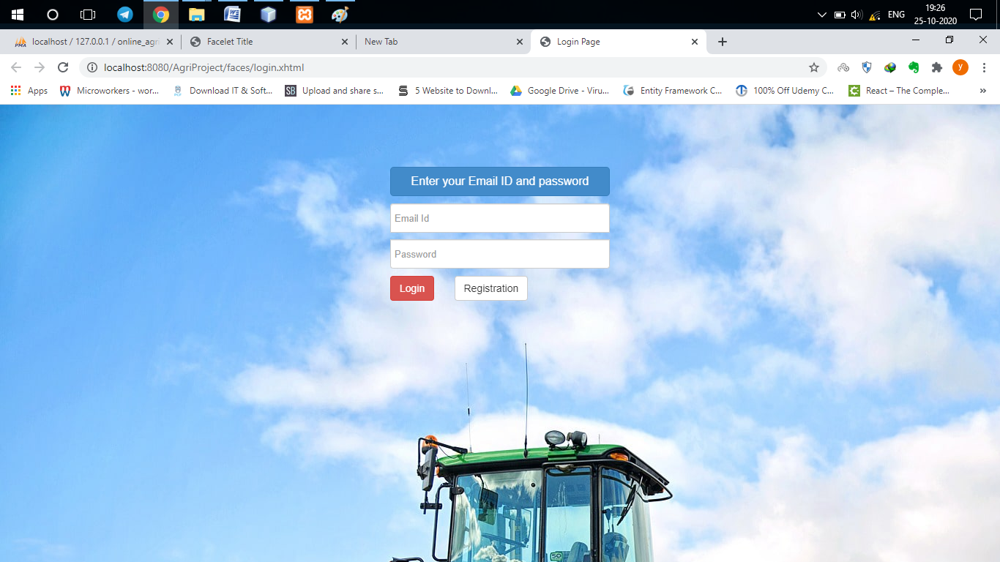

* Admin Pages:

a. Brand Page :

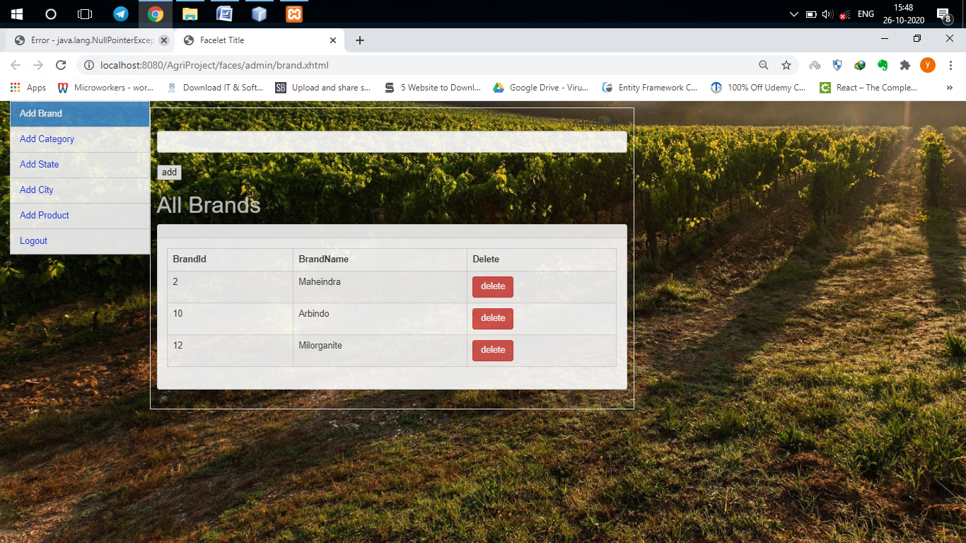

b. Category Page:

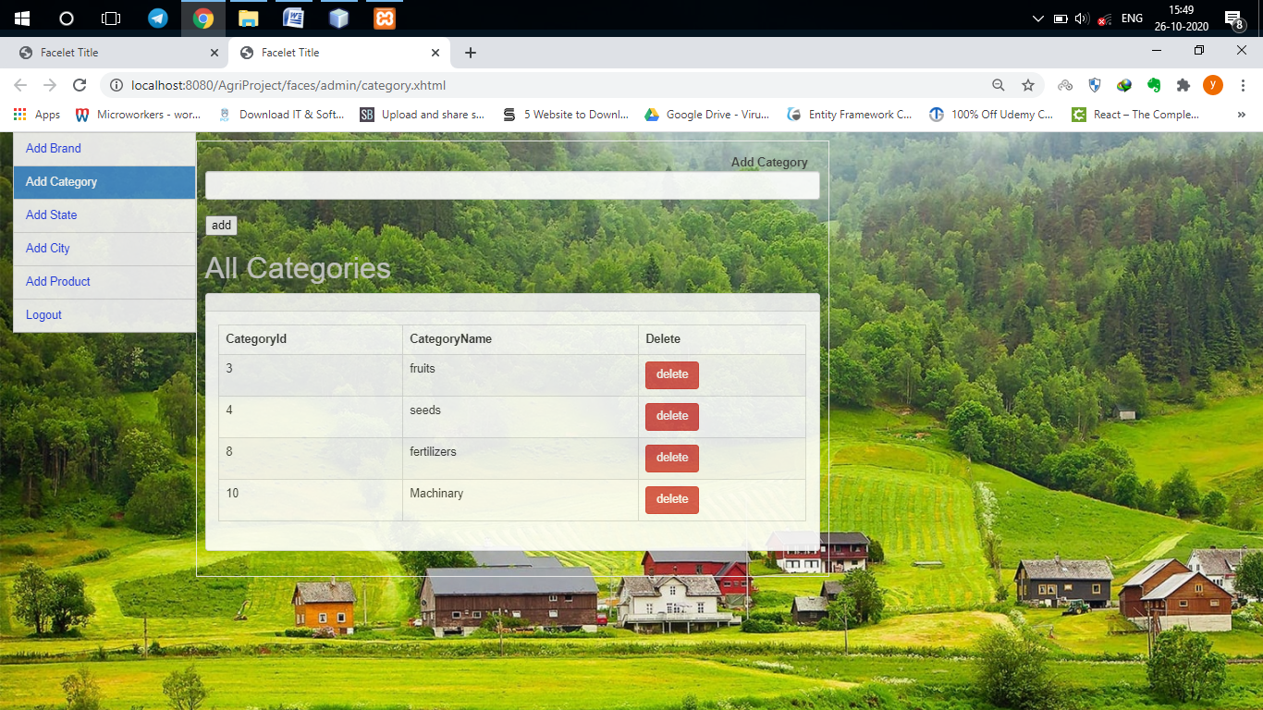

c. State Page:  
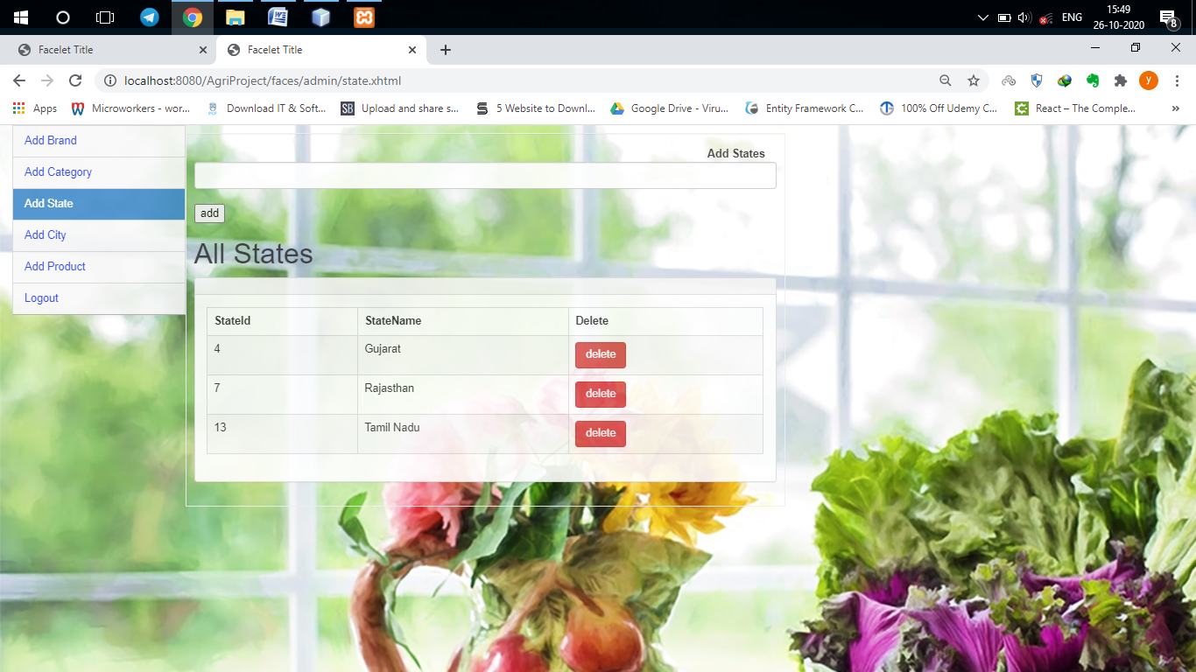

d. City Page:  
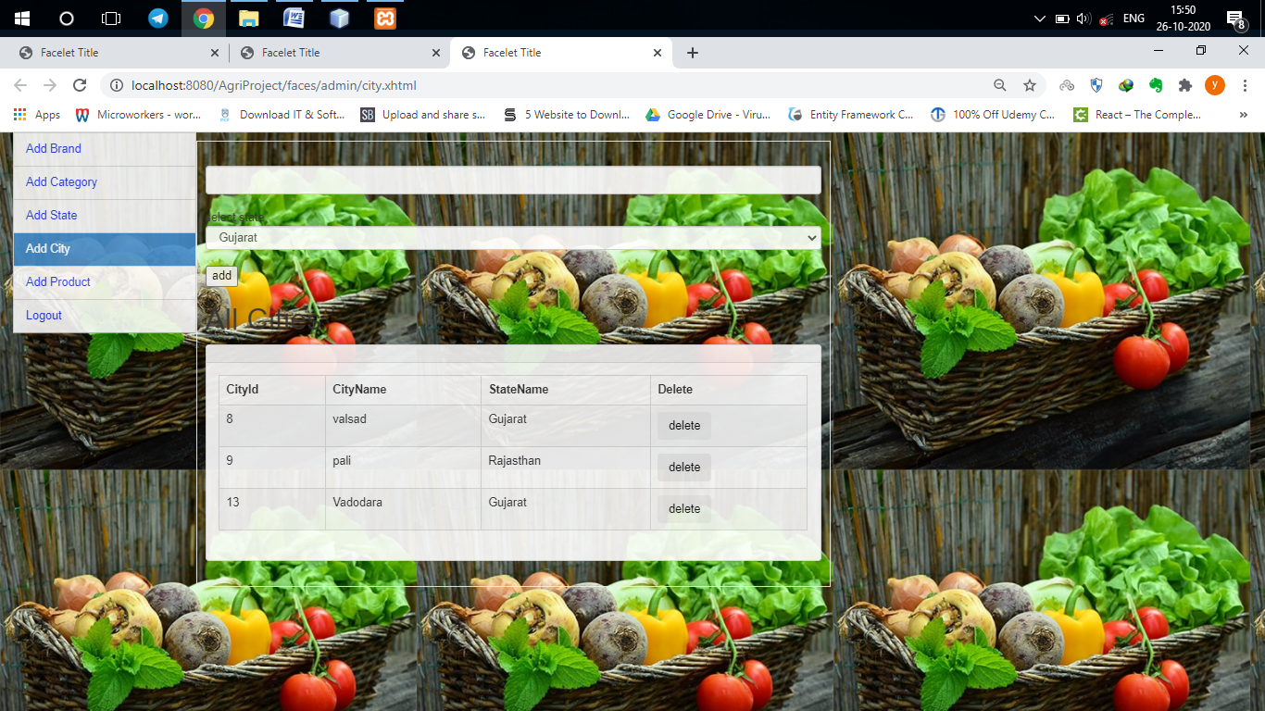

e. Product Page:

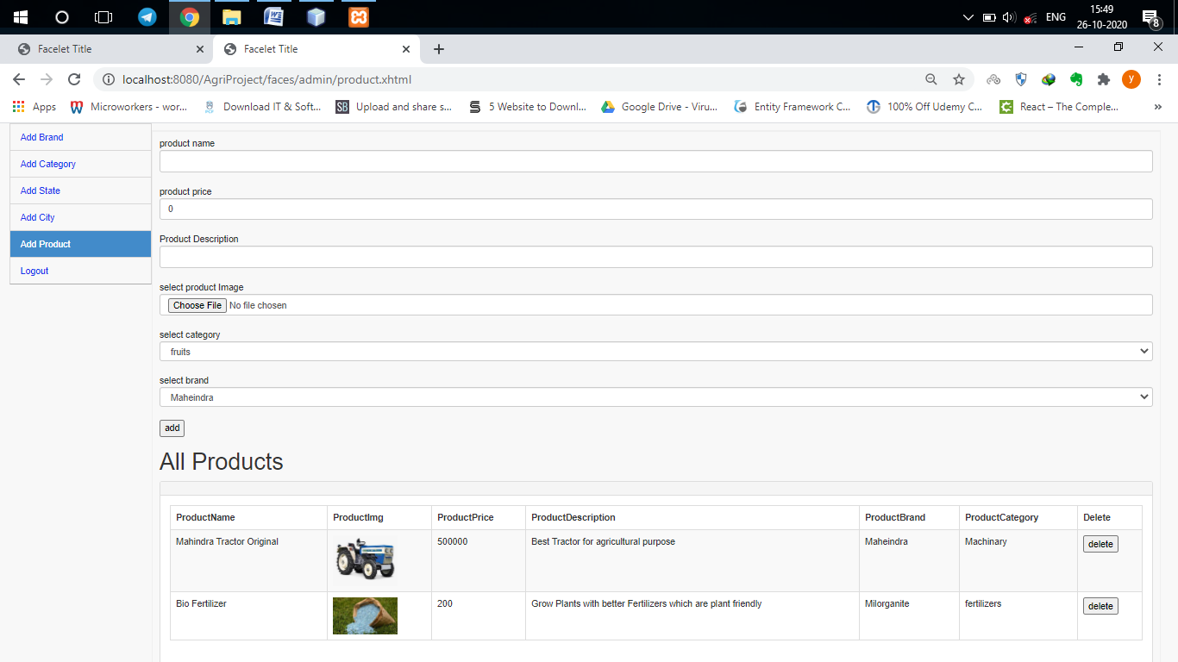

User Side:

1. Products Page:

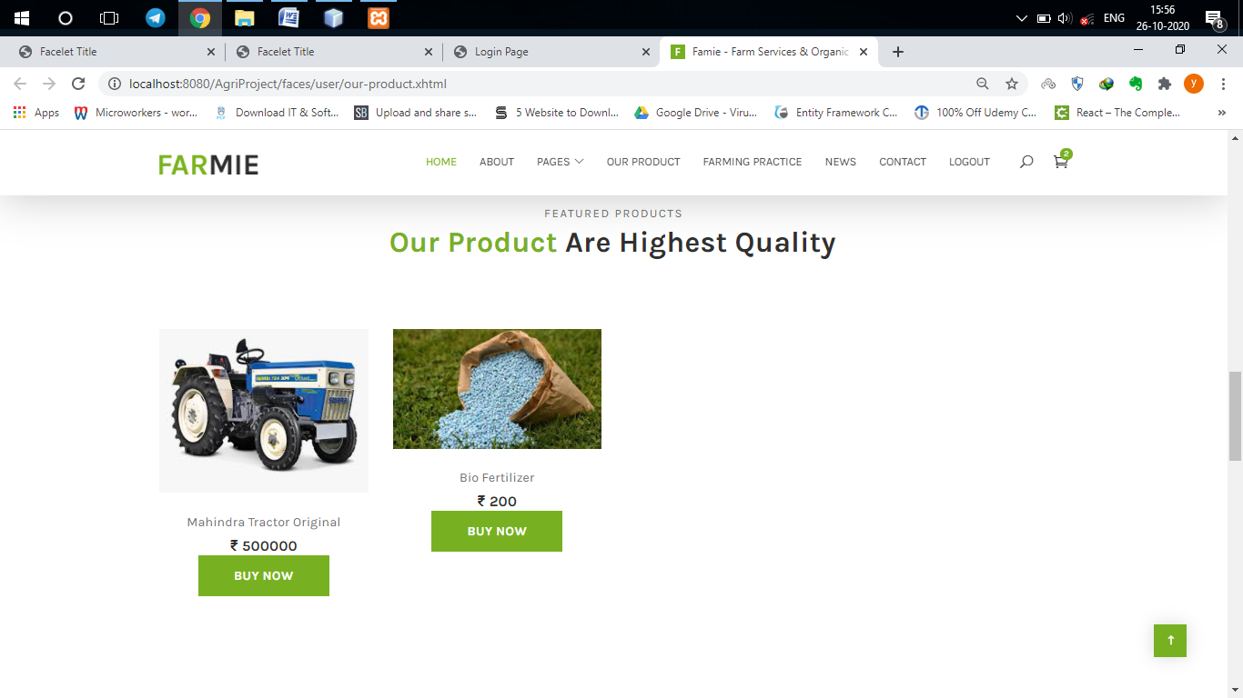

1. **Reference**

**Reference**

* <https://www.oracle.com/java/index.html>
* <https://www.javatpoint.com/>
* <https://getbootstrap.com/>
* <https://youtube.com/>
* <https://stackoverflow.com/>

1. **Future Enhancement**

* Filter Based Searching
* Chat Bot For Query
* Guest Based Login